Prior Art

Our design’s combined handheld electronic capabilities are unique to the medical catheter market. Many products use either electronic steering on a larger robotic device or use purely mechanical actuation on a handheld catheter. By combining aspects of both types of devices, we hope to find a unique niche in the medical field.

Current handheld catheters, such as JP 4194691 B2 2008.12.10 and EP 0 634 941 B1 (Figure 1 and 2), use multiple pull-wires to actuate the distal tip of the catheter. These designs can actuate in multiple planes which is desired for our design. These devices are limited by their use of multiple mechanisms to move the tip in different planes. Furthermore, they can require the use of multiple hands to operate which is undesirable for surgeons. Our device works to improve the control mechanism by creating an electronic d-pad to operate the device in multiple planes with a single, one-handed controller, differing from existing solutions to multiplanar motion. Although the mechanisms are similar, the control system of the mechanisms is novel in our design.

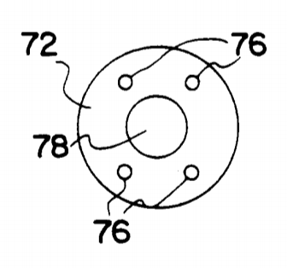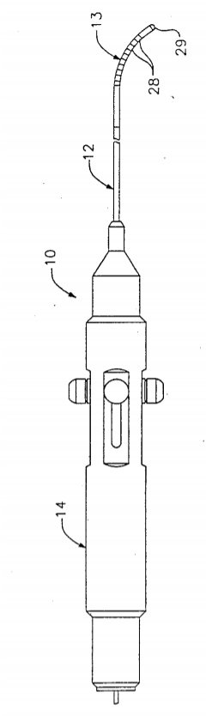

Figure 1 and 2: Handheld catheter designs from patents

Robotic catheters achieve the goal of electronic controls, but their use is limited by their cost and size. Designs like US 2018 / 0055589 A1 and US 2018 / 0132950 A1 (Figure 3 and 4) require a dedicated computer workstation to perform surgery. These stations are expensive and large which restricts surgeons’ access to them. The device itself is also costly. Hansen Medical’s Magellan Robotic System costs between 1.2 and 1.5 million dollars.

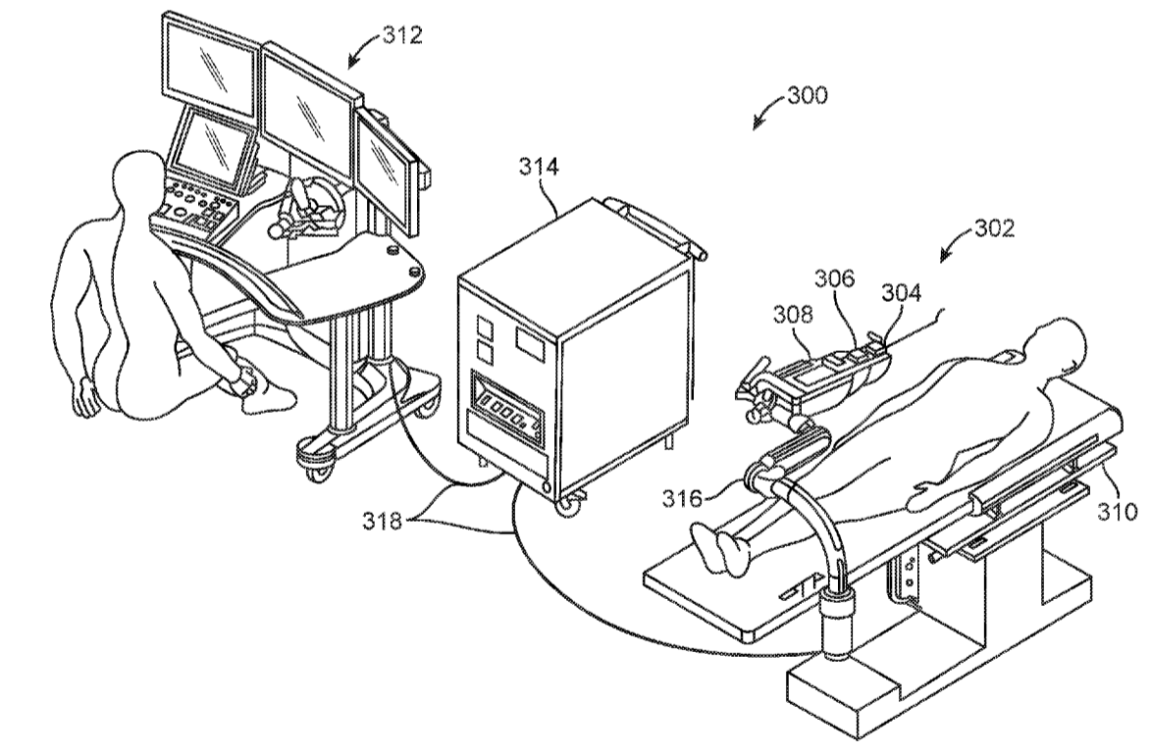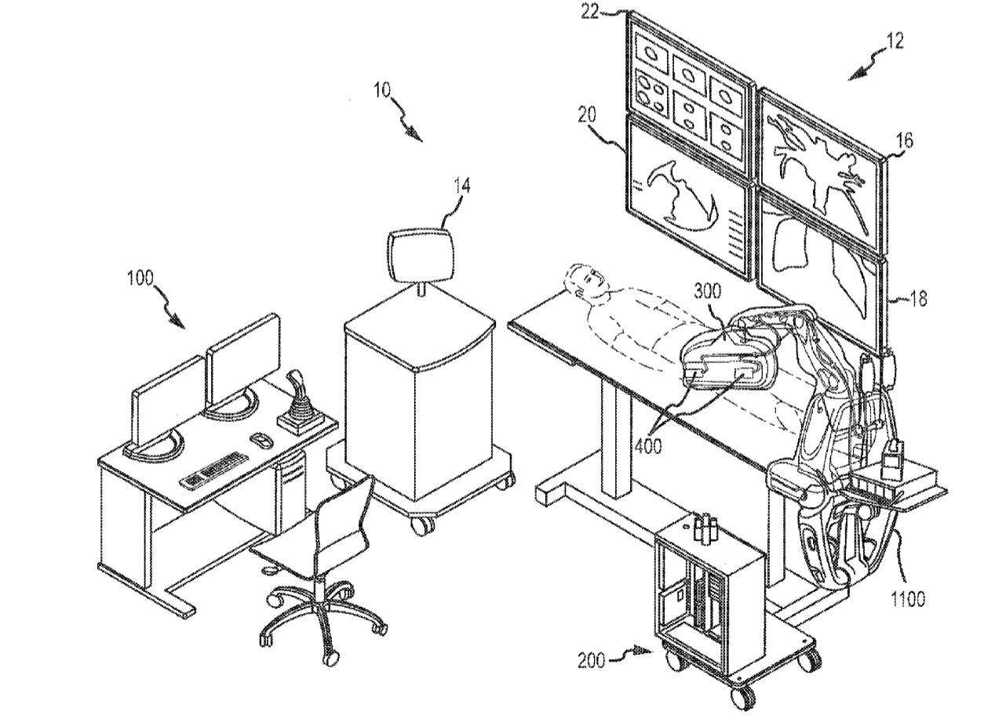

Figure 3 and 4: Patent art for robotic catheter designs